Digital Signal Processing Lab

Expt. No. 4

Power Spectrum Estimation



By Pranit Dalal

Roll no. 16EC10016

Group 22 (Tuesday)

**AIM:**

Estimation of power spectral density using

1. The Welch Nonparametric Method: Averaging Modified Periodogram
2. Parametric method: Yule-Walker AR model

**A. The Welch Nonparametric Method: Averaging Modified Periodogram**

**THEORY:**

In non-parametric method, the way the data was taken is of no concern, hence the term non-parametric.

The steps of Welch method are:

1. x(n) is divided into L overlapping blocks, each block of length M with D samples common between two successive blocks as, xi(n)=x(n+iD) n=0,1,2,3,……,M-1 i=0, 1,……..,L-1 .

2. The estimated PSD of the ith block is obtained by computing the periodogram of that block which is

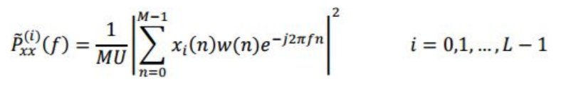

where w(n) is the window function of length M (usually, a Hamming window) and U is a normalization factor for the power in the window function defined as

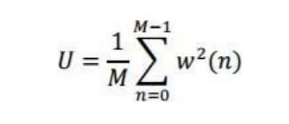

3. Now the Welch spectrum estimate is obtained by the average of these modified periodograms of all blocks, i.e.,

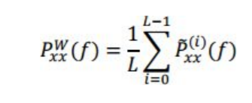

4. The estimated PSD (as above) is plotted and compared with the actual PSD using pwelch function in MATLAB.

**CODE:**

clear all;  
N = 128;  
k = 1024;  
r = randn(k,1);  
L = 63;  
%var = 1; %since sigma is considered 1(Standard deviation)  
a = [1 -0.9 0.81 -0.729];  
x = filter(1,a,r);  
M = 2*k/(L+1);  
D = M/2;  
xi = zeros(L,M);  
  
for i = 0:L-1  
 for j = 0:M-1  
 xi(i+1,j+1) = x(j+1+i*D);  
 end  
end  
  
w = hamming(M);  
U = 0;  
 for i = 1:M  
 U = U+w(i)*w(i);  
 end  
 xi = xi.*w.';  
 U = U/M;  
 f = 0:1/N:(N-1)/N;  
 P = fft(xi,N,2);  
 P = fftshift(P);  
 P = abs(P);  
 P = P.^2;  
 P = 0.16*P/(M*U); %.16 is normalisation factor for D = M/2;  
  
Z = zeros(1,N);  
  
for i = 1:N  
 for j = 1:L  
 Z(i) = Z(i) + P(j,i);  
 end  
 Z(i) = Z(i)/L;  
end  
figure;  
plot(f,Z);  
  
[pxx,s] = pwelch(x,w,D,N,'centered');  
hold on;  
plot(f,pxx);

**PLOTS:**

D=0(no overlap)

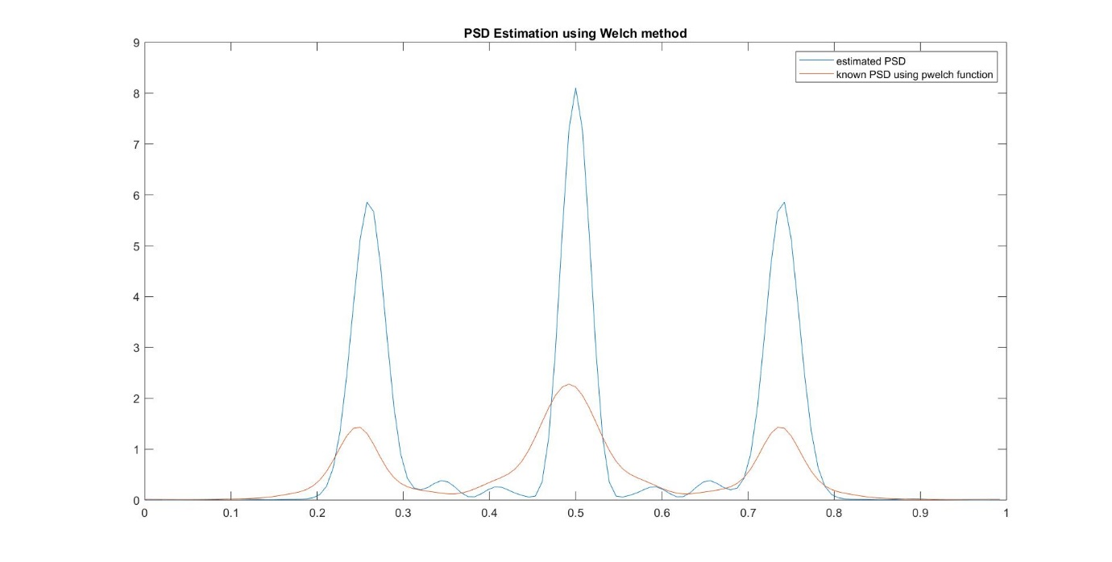

D=M/2(50% overlap)

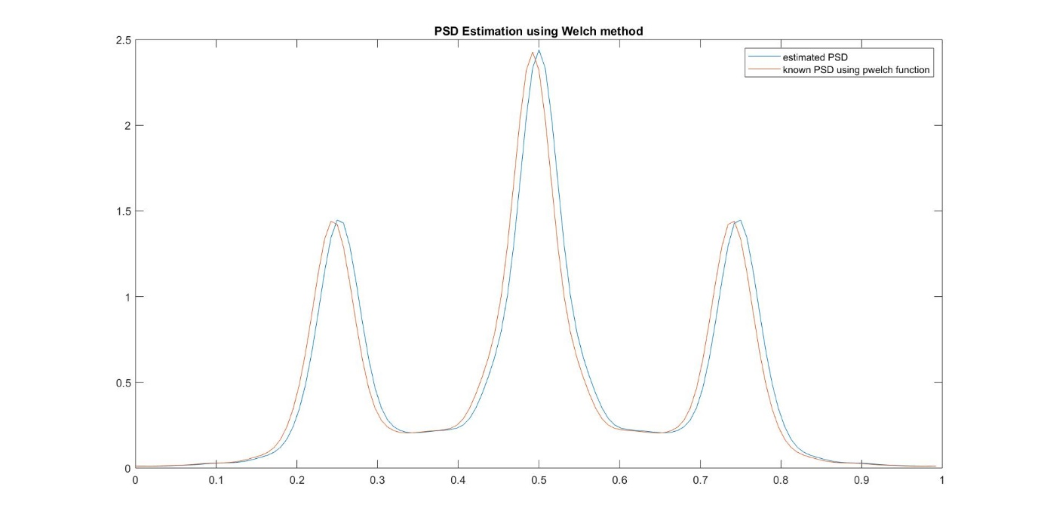

**B.** Parametric method: Yule-Walker AR model

**THEORY:**

Parametric methods are based on modelling the data sequence by a rational system function of the form

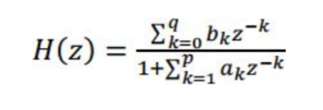

In the AR (auto regressive) process of order p, q=0 and b0=1, i.e. numerator is equal to 1.

The modern parametric method for PSD estimation exploits the prior knowledge available regarding the source of data generation. It assumes a model for that source and estimates the parameters for that particular model. No windowing occurs in this method. This is particularly useful when only a short data segment is available. The simplest model that is used in practice is a pth order AR model described by the transfer function

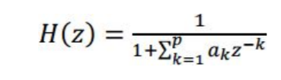

The data sequence is assumed to be generated by passing a zero mean white random sequence to the above filter.

**CODE:**

k = 1024;  
p = 128;  
N = 128;  
r = randn(k,1);  
n = 1:k;  
a = [1 -0.9 0.81 -0.729];  
x = filter(1,a,r);  
[y,b] = autocorr(x,p);  
R = zeros(p);  
for i = 1:p  
 for j = 1:p  
 R(i,j) = y(abs(j-i)+1);  
 end  
end  
Y = y(2:p+1);  
A = -1*(inv(R))*Y;  
var = 0;  
for i=1:p  
 var = var+A(i)*Y(i);  
end  
var = var+y(1);  
var = sqrt(var);  
h = zeros(p+1,1);  
h(1) = 1;  
h(2:p+1) = A(1:p);  
h = h.';  
[H,F] = freqz(1,h,k);  
plot(F/(2*pi),20*log10(var.*abs(H)));  
Z = filter(1,h,r);  
[Pxx,F] = pyulear(Z,128,k,1);   
hold on;  
plot(F,10*log10(Pxx));

**PLOTS:**

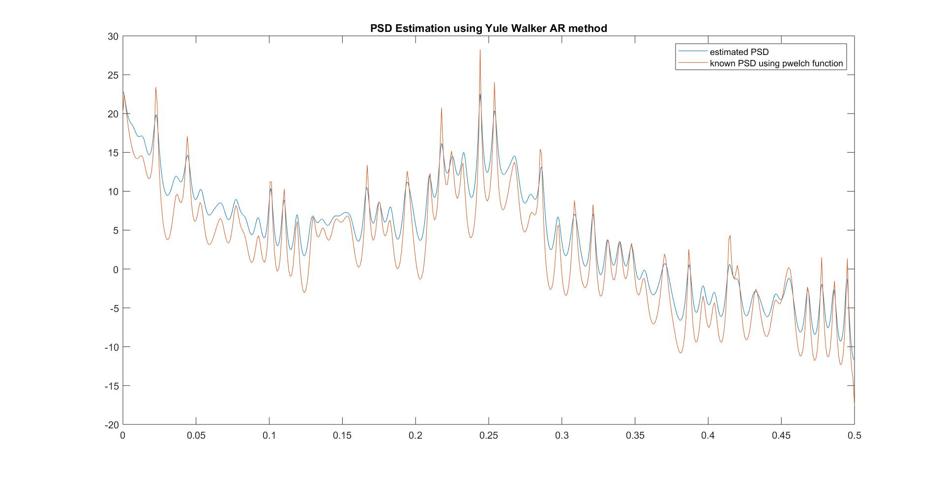

**DISCUSSIONS:**

1. The power spectral density is the Fourier transform of autocorrelation.
2. In welch non-parametric method, we divide the data into smaller blocks and estimate the power spectral density using a hamming window.
3. In Yule-Walker AR model no windowing occurs and this is particularly used when short data segment is available.
4. Yule-Walker uses the AR-model parameters to calculate the Power Spectral Density (PSD). In this it is assumed that white random noise is passed through a filter to produce a random sequence.
5. We can calculate the actual PSD of the sequence because we have the filter coefficients.

[*Published with MATLAB® R2018a*](https://www.mathworks.com/products/matlab)